Serial Pattern Detection System with One-Second BCD Display Using Verilog
The Domain of the Project:
VLSI Design — RTL Design using Verilog HDL

Course Name
VLSI Design - SURE Trust

Team Mentor and Designation:
Dev Chadha sir, R&D Engg @ Qbit Labs Pvt

Team Member:
Byanajjara Ganesha

Period of the Project
1 Month

Declaration
The project titled "Serial Pattern Detection System with One-Second BCD Display Using Verilog" has been mentored by Dev Chadha sir, organised by SURE Trust, for the benefit of the educated unemployed rural youth for gaining hands-on experience in working on industry relevant projects that would take them closer to the prospective employer. I declare that to the best of my knowledge the members of the team mentioned below, have worked on it successfully and enhanced their practical knowledge in the domain.

Team Member:
Byanajjara Ganesha

Mentor's Name: Dev Chadha Sir
Designation — Company Name: , R&D Engg @ Qbit Labs Pvt

Prof. Radhakumari
Executive Director & Founder
SURE Trust

Table of Contents
- Executive Summary
- Introduction
- Project Objectives
- Methodology & Results
- Social / Industry Relevance of the Project
- Learning & Reflection
- Future Scope & Conclusion

1. Executive Summary
This project presents the design and functional verification of a Serial Pattern Detection System with a real-time, one-second-updated BCD/seven-segment hit-count display, implemented entirely in Verilog HDL. The system serialises an incrementing parallel data word one bit per clock cycle through a self-timed transmitter, while a receiver continuously monitors the serial stream with a 9-bit shift register to detect a fixed target pattern. Every detected match (a “hit”) is accumulated in a counter that is latched and reset once every second, using a dedicated 10,000-cycle timer referenced to the system's 10 kHz clock. The latched binary count is converted to Binary-Coded Decimal using the double-dabble algorithm and decoded to drive a three-digit seven-segment display, giving a continuously updating, human-readable read-out of detections per second. All seven RTL modules were integrated into a single top-level design and verified through simulation using a dedicated testbench, confirming correct handshaking, pattern detection, timing, and display behaviour end-to-end.

2. Introduction
Background and context: Serial-to-parallel data framing, fixed-pattern recognition, and time-referenced digital counters are foundational building blocks that recur throughout digital communication and embedded-system design — from UART/USART peripherals to protocol analysers and real-time instrumentation displays. This project was undertaken to design and verify, from first principles in Verilog HDL, a self-contained system that exercises all three building blocks together in a single, cohesive datapath.
Problem statement / goals: Build an RTL system that (a) converts a parallel data word into a serial bitstream with proper handshaking, (b) reliably detects a specific, fixed 9-bit pattern arriving over that serial line, (c) counts how many matches occur within each one-second window, and (d) displays that count on a live three-digit seven-segment read-out that updates once per second.
Scope and limitations: The design is implemented and verified at the RTL/simulation level on a single 10 kHz clock domain, with the on-chip receiver observing the same serial line the transmitter drives — a self-contained loopback arrangement rather than a physically separate two-chip link. The per-second hit count is carried on a 10-bit register, comfortably covering the maximum detection rate the transmitter can physically produce at this clock rate. This iteration covers RTL design and functional simulation only; physical FPGA/board bring-up was outside its scope.
Innovation component: Rather than using an arbitrary bit pattern for the detector, the 9-bit target value (110010100) was deliberately constructed by concatenating a 4-bit month field (1100 = 12) with a 5-bit day field (10100 = 20), encoding the author's own birth date, 12/20, as the detection target — a small but deliberate design choice that made the pattern personally verifiable while still exercising the same shift-register matching logic a generic UART frame-sync or protocol-header detector would use in industry.

3. Project Objectives
- Design a parallel-to-serial transmitter (serial_transmitter) with a one-cycle “ready” handshake pulse every 10 bits
- Design a free-running data source (tx_counter) that supplies a new 10-bit word each time a frame completes
- Design a 9-bit shift-register-based pattern detector (serial_detector) on the receive path
- Implement a 1-second reference timer (10,000 cycles at 10 kHz) to gate periodic reporting
- Accumulate pattern hits per second and latch the count on each timer expiry
- Convert the latched binary hit count to BCD (bin2bcd, double-dabble algorithm) and drive a 3-digit seven-segment display (seg7)
- Integrate all sub-modules into a single top_module and verify end-to-end behaviour with a self-checking testbench (tb_serial_system)
Expected outcomes / deliverables: Seven synthesisable RTL modules, an integration testbench, and simulation waveforms demonstrating correct transmit, detect, count-and-latch, and display behaviour — version-controlled and published to a public GitHub repository.

4. Methodology & Results
Methods / Technology used: The design was implemented entirely in Verilog HDL using synchronous, positive-edge-triggered logic for all sequential elements and pure combinational logic for the BCD conversion and seven-segment decode stages. Pattern detection uses a continuously-shifting 9-bit register compared against a fixed target every clock cycle. Binary-to-BCD conversion uses the classical double-dabble (shift-and-add-3) algorithm, implemented as a 10-iteration combinational loop.
Tools / Software used: Verilog HDL for RTL design. [Add the specific simulator/waveform viewer and version you used — e.g. Icarus Verilog + GTKWave, ModelSim, or Xilinx Vivado Simulator.]
Data collection approach: Not applicable — this is a hardware-description design/verification project rather than a data-driven one; input stimulus is generated internally by the testbench rather than collected from an external dataset.

Project Architecture
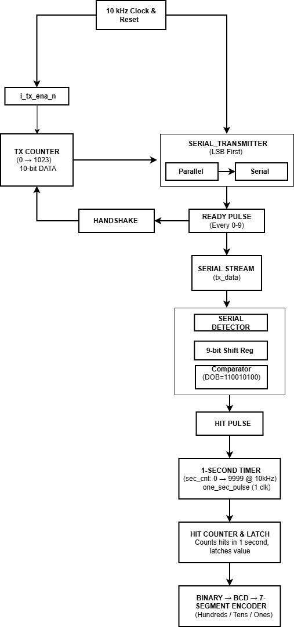

Figure 1: Transmit-Receiver Based Pattern Detection System

The architecture is organised around a single top_module that instantiates six sub-modules on a shared 10 kHz clock. On the transmit side, tx_counter produces a new 10-bit data word each time the previous frame finishes, and serial_transmitter shifts that word out one bit per clock, least-significant bit first, asserting a one-cycle ready pulse after every 10 bits. The resulting serial line, o_serial_out, is simultaneously the transmitter's output and the input the on-chip receiver monitors — the design is a self-contained loopback rather than two physically separate ends. serial_detector shifts each incoming bit into a 9-bit register and flags a hit whenever that register equals the fixed target pattern. In parallel, a 14-bit counter inside top_module counts 10,000 clock cycles — the number of 10 kHz clock periods in one second — and pulses one_sec_pulse once every second; hits are tallied continuously and the running tally is latched into hit_count_latched (with the accumulator then cleared) exactly on that pulse, so the displayed value always reflects a complete, settled one-second window rather than a mid-count snapshot. bin2bcd converts the 10-bit latched count into three BCD digits, and three instances of seg7 decode those digits into active-low seven-segment patterns, so the display refreshes once per second with the previous second's hit count.

Final Project Working Screenshots

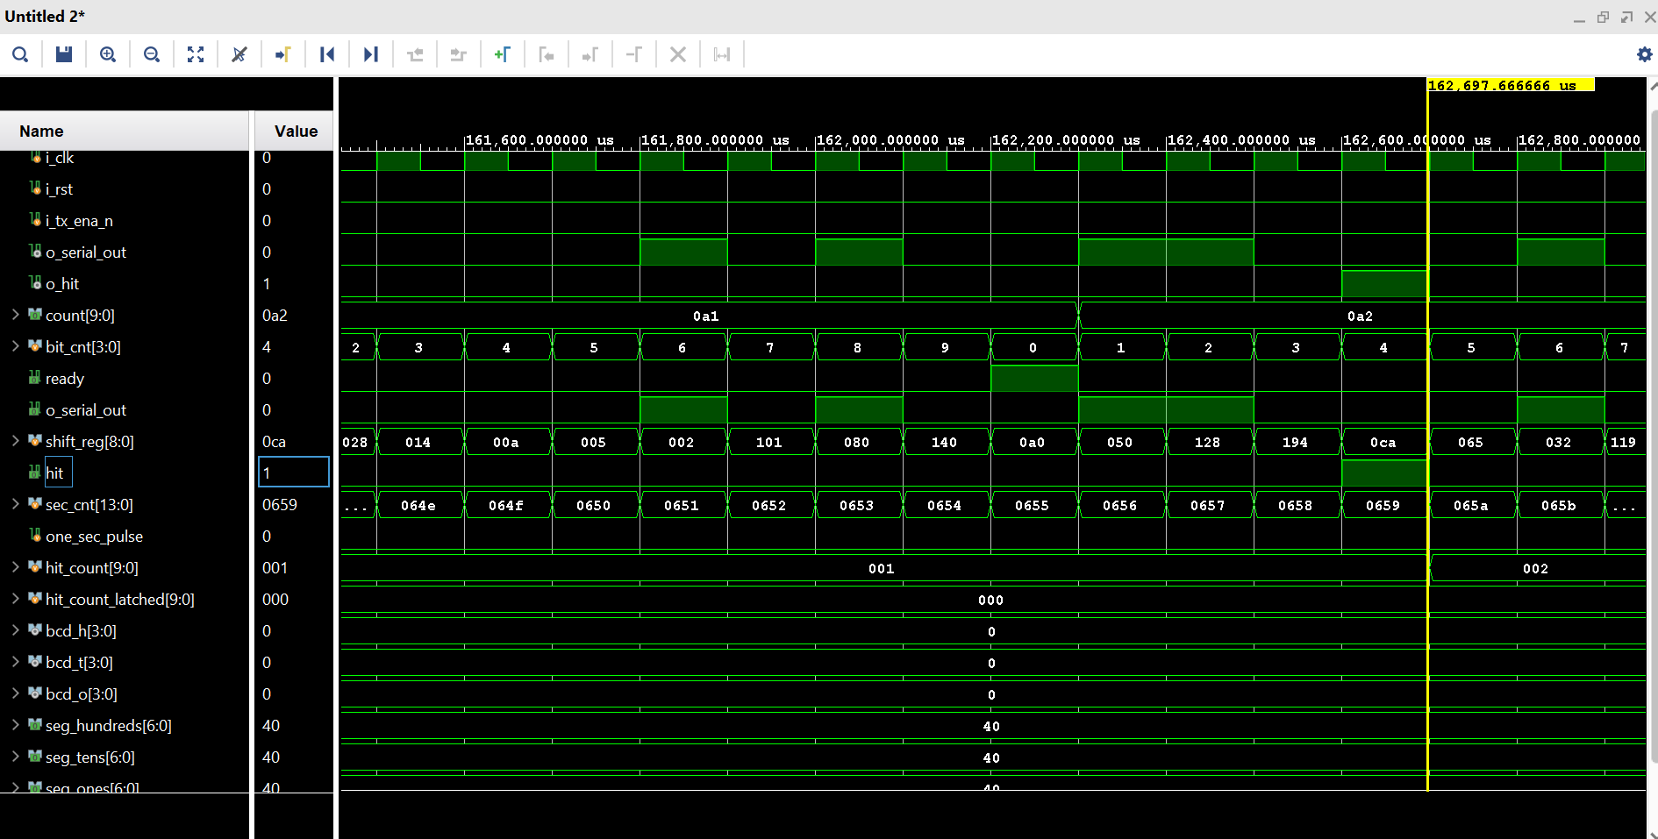
[Figure 2] Waveform — ready & hit signals
Figure 2 shows the transmitter's ready pulse firing once every 10 clock cycles as each frame completes, with the receiver's hit output pulsing high whenever the shift register captures the target pattern on the shared serial line — confirming the transmit-handshake and pattern-match logic operate correctly together.

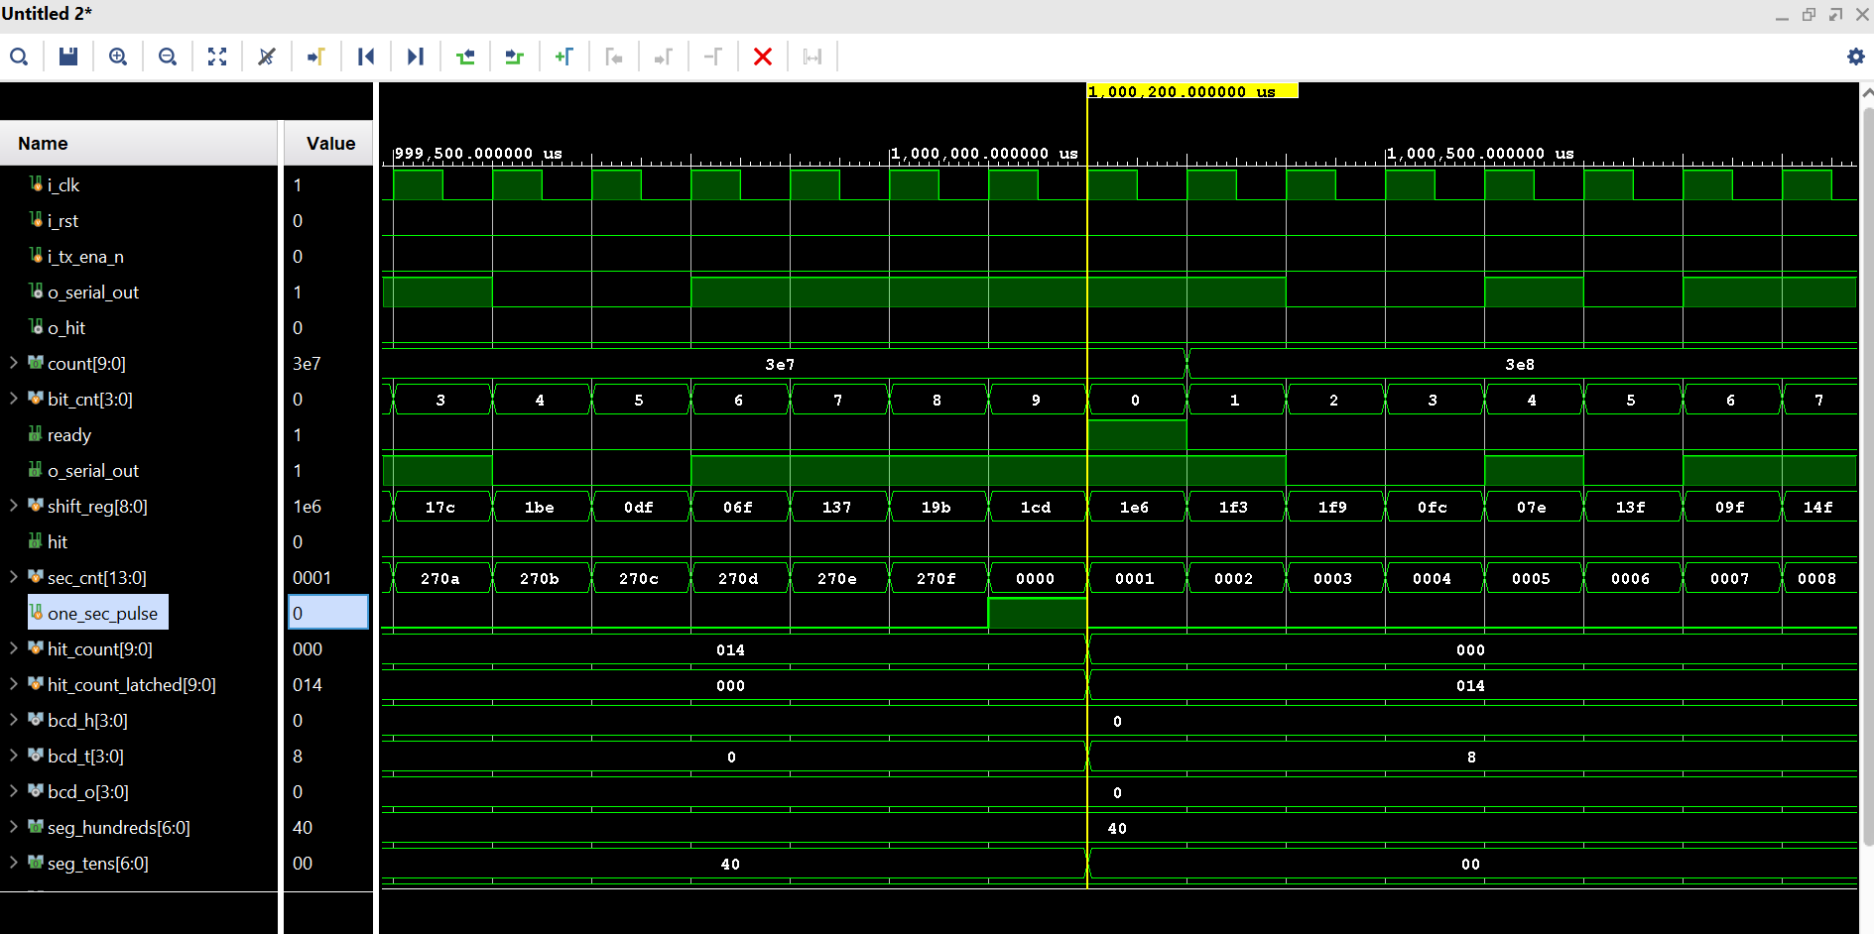
[Figure 3] Waveform — second counter [13:0] & one-second pulse
Figure 3 shows the 14-bit second counter free-running from 0 to 9999 (0x270F) and one_sec_pulse asserting for exactly one cycle at that count — confirming the one-second reference timer is correctly calibrated to the 10 kHz system clock.

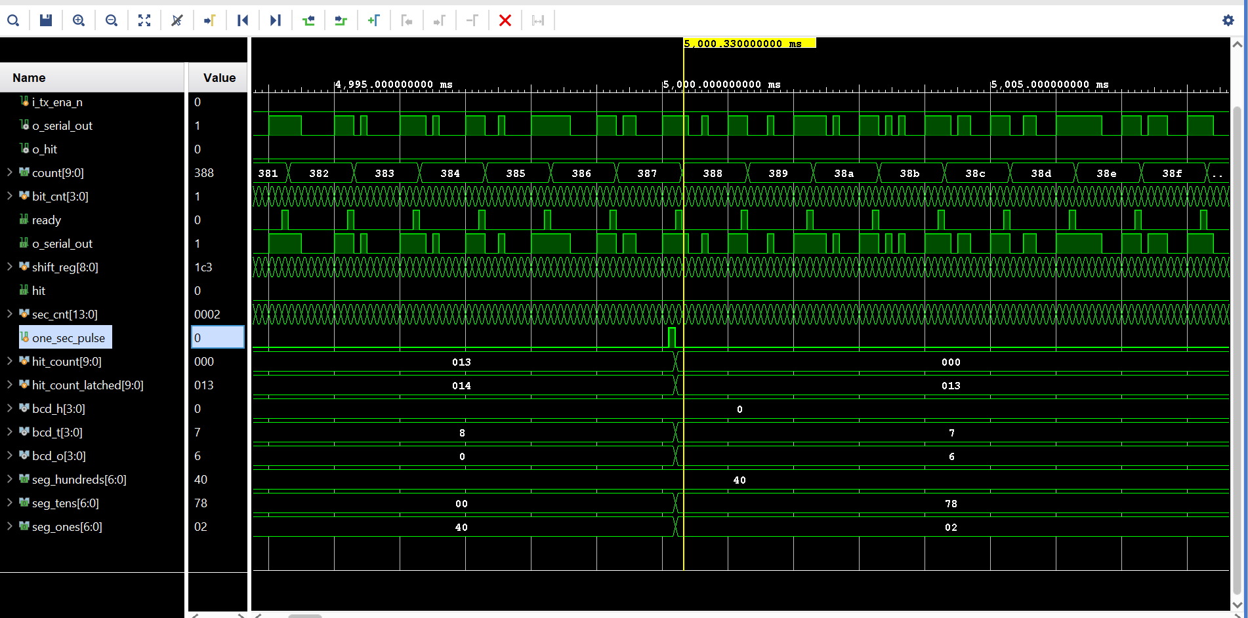
[Figure 4] Waveform — binary-to-BCD and BCD-to-seven-segment conversion
Figure 4, captured once one_sec_pulse falls and outputs have settled for that interval, shows the latched hit count correctly converted to its three BCD digits and further decoded to the corresponding seven-segment patterns — confirming correct timing and display functionality end-to-end.
Project GitHub Link: https://github.com/Ganesha-Byanajjara8123/Serial-Pattern-Detection-System-with-One-Second-BCD-Display-Using-Verilog

5. Social / Industry Relevance of the Project
Serial framing, pattern/frame-sync detection, reference timers, and BCD/seven-segment read-outs are not academic curiosities — variations of each block appear directly in UART/USART peripherals, protocol analysers, real-time counters, and digital instrumentation used throughout the semiconductor and embedded-systems industry. Building and verifying each of these blocks individually, then integrating them into one working datapath, gives direct, demonstrable practice with the kind of module-level RTL design and simulation-based verification that entry-level RTL Design and Design Verification roles expect candidates to be able to discuss and defend.
Within SURE Trust's broader mission of equipping educated but unemployed rural youth with industry-relevant, hands-on experience, this project served as a concrete, portfolio-ready demonstration of that translation — turning classroom digital-design theory into a self-contained, version-controlled, publicly documented RTL project that can be discussed in technical interviews.

6. Learning & Reflection
New technical learnings (per team member): Strong RTL designing, Basic Digital Design, FSM, Register, Hand Shake method, BCD, Clk & Frequencey Taken.
New tools / process learnings (per team member): EDA Playground, Notpad++(Edit), Vivado.
Overall experience (per team member): This project Taught me New concepts, Skills & Workflow of project. Dev sir Teach us very well.

7. Future Scope & Conclusion
Recap of objectives and achievements: This project successfully achieved its stated objectives: a parallel-to-serial transmitter with proper frame handshaking, a shift-register-based fixed-pattern detector, a calibrated one-second reference timer, per-second hit accumulation and latching, and a live binary-to-BCD-to-seven-segment display path — all integrated into a single top-level module and verified through simulation.
Future scope:
- Physical FPGA realisation driving a real seven-segment/board interface, rather than simulation only
- A configurable, run-time-programmable target pattern (currently a fixed value) to support arbitrary frame-sync values
- Proper UART-style framing (start/stop/parity bits) instead of a raw back-to-back bit stream, for robustness against real transmission-line noise
- Separate transmit and receive clock domains with proper clock-domain-crossing synchronisation, for a true two-chip serial link rather than a shared-clock loopback
- Formal verification (SystemVerilog Assertions) on the pattern-match and one-second-timing logic to complement the existing simulation-based testbench
- Extending the hit counter and display to more digits to support higher-throughput detection scenarios

